Workshop
  - Practical Spec-Driven Development with Windsurf and GitHub Spec Kit

1. Purpose of the workshop
This workshop is a hands-on session for developers and other technical attendees who want to learn how to use Windsurf as the IDE and GitHub Spec Kit as the SDD toolkit in a realistic development flow.
The session is intentionally practice-first. It is not a theory session about AI history, prompt engineering basics, or agents in general. The focus is on using the tools directly in a project, following a presenter-led flow, and then applying the same process independently.

2. Target audience
This workshop is intended for:
- developers,
- technical leads,
- QA engineers / automation engineers,
- and other technical colleagues who are comfortable working in a codebase, terminal, and IDE.
It assumes the attendees are already familiar with common development concepts such as:
- Git repositories,
- project setup,
- package installation,
- project structure,
- and basic prompt-based interaction with AI tools.
The workshop is not designed for complete beginners.

3. Workshop format
The workshop will be structured as a follow-along practical session and it will run for approximately 160-180 minutes with 2 pauses of 10-15 minutes between the 3 parts.
First part: Environment check, Windsurf orientation, Prompt warm-up, Workflows and Skills
Second part: SDD, Spec Kit
Third part: Guided end-to-end feature implementation, Solo exercise, Q&A
The presenter will demonstrate each step live, and attendees will execute the same steps on their own machines. Most of the session will be interactive, with only a short theory segment to explain the SDD flow and why Spec Kit uses a staged process instead of one-shot prompting (or vibe coding).

4. What this workshop is and is not
This workshop is
- a practical workshop,
- a how-to session,
- a guided exercise in using Windsurf and Spec Kit inside a real project,
- a session where attendees will complete a full SDD flow for a feature.
This workshop is not
- a history of LLMs or AI agents,
- a general introduction to prompting,
- a conceptual lecture on AI tools,
- a deep theory session on software process.

5. What attendees need before the workshop (prerequisites)
The workshop depends heavily on the environment already being ready. If the setup is incomplete, attendees will not be able to follow the guided flow effectively.
Note 1: Run the terminal always as administrator (right click -> Run as Administrator). If some command is restricted in the current terminal program, try another terminal program (example, use PowerShell, Bash, Command Line, etc.. any terminal you have installed on the PC) – because we have different restrictions on different machines.
Note 2: All the green letters are terminal commands, you’ll need to execute these commands in terminal.
Note 3: The tools versions are not that important if everything works fine (the app, the ide, the terminal, etc…). The tool’s versions you’ll be seeing below are the latest official versions that were available at the moment of writing the manual. It’s fine if you have older or newer version and everything works as expected.
All attendees must complete these prerequisites before joining the session:

5.1 Obtain and install Windsurf
- Note: Windsurf profile with the token usage (ACUs) https://windsurf.com/profile

5.2 Optional: Create GitHub account
To get the workshop’s exercise attendees could just download the repo (as zip), or clone the repo locally, or fork+clone the repo:
- Create GitHub account https://github.com/
- Workshop GitHub Repo https://github.com/MTrajK/engineering-notes
- Workshop location inside the repo https://github.com/MTrajK/engineering-notes/tree/main/SDD%20Workshop
- use SSH keys to communicate with GitHub (or use PAT tokens, whatever you prefer)
  - generate SSH key pair on the local machine (ssh-keygen -t ed25519 -C "<comment>")
  - start ssh-agent (Set-Service ssh-agent -StartupType Manual and Start-Service ssh-agent in windows) and add private key (ssh-add ~/.ssh/id_ed25519)
  - and add the SSH key to your GitHub account (find the generated key file locally ~/.ssh/<algorithm name, example ed25519>.pub)
  - check if the git ssh connection is successful (ssh -T git@github.com)

5.3 Install and verify git
To access GitHub attendees must:
- Install Git 2.54.0.0 (x64) (or newer version if available) from https://git-scm.com/install/ for MacOS / Linux / WSL)
git --version

5.4 Have access to the project source
Attendees must have the project source available locally before the workshop starts:
- Project location (for Windows OS): https://github.com/MTrajK/engineering-notes/tree/main/SDD%20Workshop/SDD%20Workshop%20Windows
  - Only for Unix-like machines (MacOS, Linux, WSL) project location: https://github.com/MTrajK/engineering-notes/tree/main/SDD%20Workshop/SDD%20Workshop%20UNIX
  - Without SpecKit installed project (only for MaxOS, Linux, WSL – not for Windows) project location: https://github.com/MTrajK/engineering-notes/tree/main/SDD%20Workshop/SDD%20Workshop%20Empty
- The preferred option is git clone, not another option
git clone git@github.com:MTrajK/engineering-notes.git

Reason:
Spec Kit’s workflow is Git-aware and uses the current git branch to detect the active feature context. That makes Git-based usage more natural and reliable during the workshop flow.
- Optional - Git Setup (in case it is not configured globally with the GitHub account)
git config --local user.email "email@email.com"
git config --local user.name "Name Surname"

5.5 Install and verify Node.js
Attendees must have Node.js available and be able to run the project setup commands required by the workshop. Validate if the NodeJs was installed successfully:
- Install Node.js Latest 25.9.0 (or newer version if available) - install it following https://nodejs.org/en/download for MacOS / Linux / WSL
node --version
npm --version

5.6 Install project dependencies
Attendees must run the project setup steps in advance (inside the project location), including:
npm install

5.7 Start the project locally
Attendees should verify that the project is runnable locally:
npm run dev
After this command in browser open http://localhost:5173/ and verify the application is runnable.

5.8 Install the Playwright Chromium binaries and run the E2E tests
Attendees should install the Playwright Chromium binaries:
npx playwright install chromium
npx playwright chromium --version
Note: If the installation stays here for a long time (sometimes it will need more than 30 seconds to execute this step) – the playwright is not installed successfully (see the solution below).
Verify that the E2E tests are runnable locally:
npm run test:e2e
After this command, 2 from 9 E2E tests must fail (this is intentional).
Solution:
If all the 9 tests are failing or if the installation is not successful, then try these steps (but remember, use the terminal as administrator):
1. Go to %USERPROFILE%\AppData\Local\ and delete ms-playwright folder (or using this command npx playwright uninstall --all)
2. Uninstall playwright node modules from the project using this command npm uninstall @playwright/test
3. Install the playwright node modules inside the using this command npm install @playwright/test
4. Install the playwright binaries again using this command npx playwright install chromium npx playwright install chromium
5. Run the E2E tests again npm run test:e2e
Alternative solution:
If the above solution does not work, then try this one:
1. Inside the repo you’ll find a folder Installation with ms-playwright.zip, download that file.
2. Extract that file into %USERPROFILE%\AppData\Local\ and you’ll get %USERPROFILE%\AppData\Local\ structure with 4 folders inside (chromium-1223, ffmpeg-1011, chromium_headless_shell-1223, winldd-1007) – more info from where these folders are downloaded in the README.md file.
3. Run the E2E tests again npm run test:e2e

5.9 Have access to the workshop resources
Attendees should have the workshop resources folder available locally before the workshop starts (from here we’ll be copy pasting prompts, workflows, skills, etc…):
- Workshop resources location: https://github.com/MTrajK/engineering-notes/tree/main/SDD%20Workshop/Resources

5.10 Pre-workshop validation checklist
Before attending, each participant should be able to confirm all of the following:
- Windsurf opens successfully
- GitLab access granted and SSH setup
- Git installed
- the project opens locally
- Node.js and npm are available
- npm install completed successfully
- npm run dev is successful and the application is up on http://localhost:5173/
- npx playwright install chromium completed successfully
- npm run test:e2e shows only 2 failing tests
- the workshop resources are available locally

6. Workshop structure

Section 1 — Environment check and workshop framing/intro
Duration: 5 minutes
Goal
Ensure everyone is in the correct environment before the real workshop starts.
What will happen
- confirm that attendees are using the prepared environment,
- confirm repository access,
- confirm Windsurf is open and working,
- confirm terminal access and project readiness,
- explain that the session will be practical and follow-along.
Outcome
Everyone is synchronized before tool usage begins.
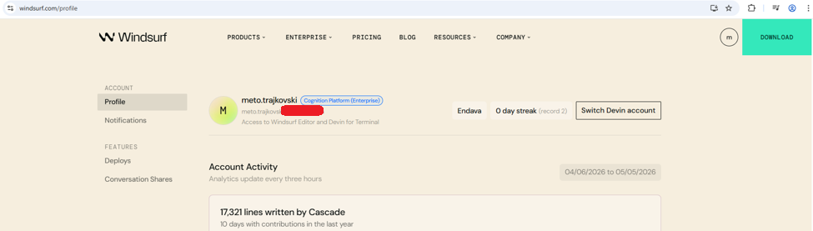
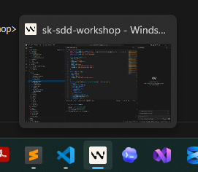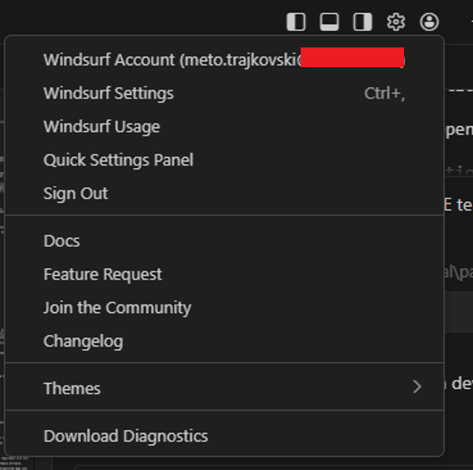
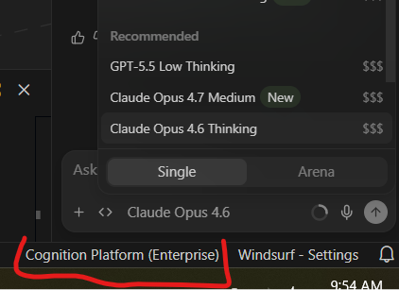
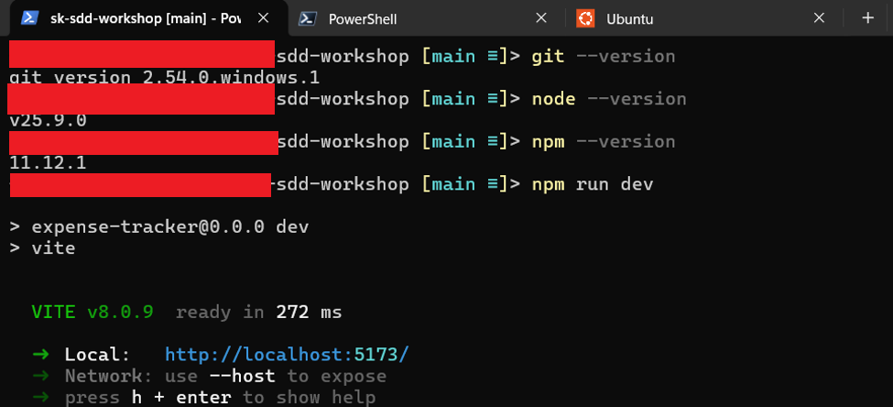
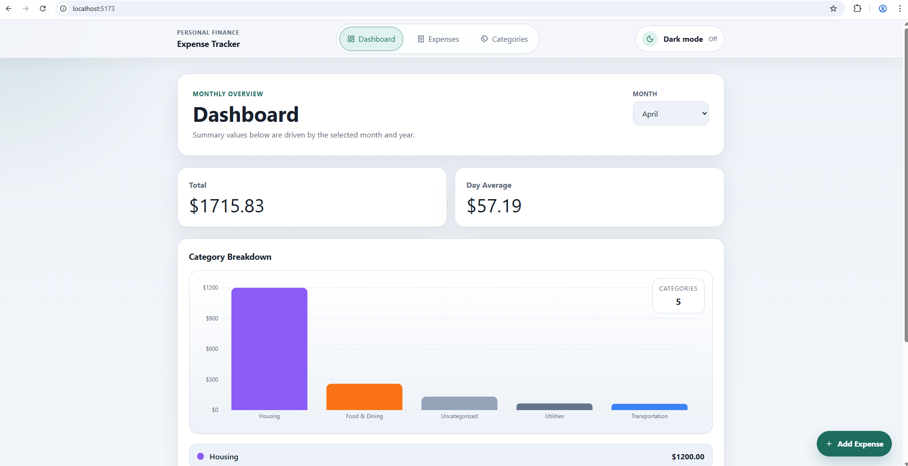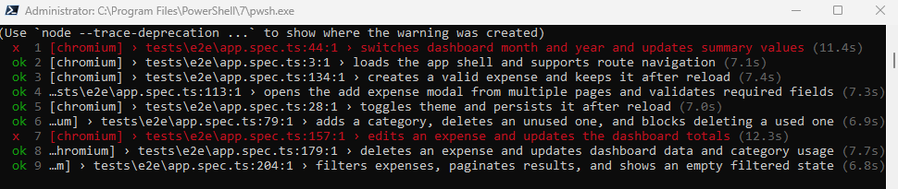

Section 2 — Windsurf orientation
Duration: 15 minutes
Goal
Introduce only the Windsurf functionality needed for the workshop.
Topics
- layout and main UI areas,
- project explorer,
- terminal usage, (NOTE: some of attendees could be facing issues with the Windsurf terminal usage, in that case they can continue using the terminal that works for them)
- mode switching,
- model selection,
- context usage,
- accepting and reviewing generated changes.
Outcome
Attendees can navigate Windsurf and understand where the workshop actions will happen.
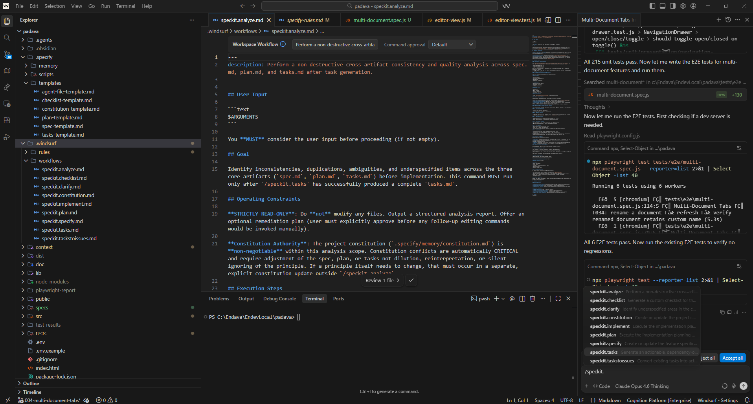
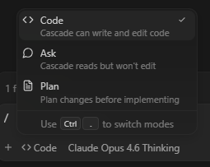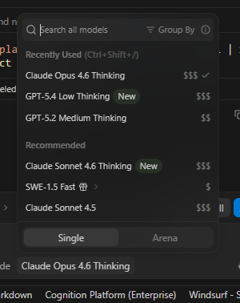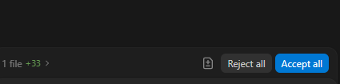

Section 3 — Prompt warm-up in Windsurf
Duration: 20 minutes
Goal
Get attendees comfortable with interacting in the IDE before introducing the full SDD flow.
Topics
- one simple read-only prompt,
- one planning-oriented prompt,
- one code-oriented prompt,
- compare the difference between asking for information, planning, and executing.
Outcome
Attendees understand the practical difference between the Windsurf interaction modes and how to use them intentionally.
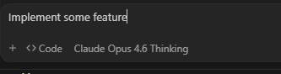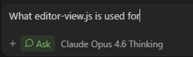
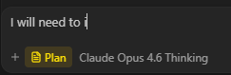

Section 4 —Workflows and Skills in Windsurf
Duration: 20 minutes
Goal
Explain the minimum required mental model for understanding how /speckit.* commands are used inside Windsurf.
Topics
- explain the difference between Rules, Workflows, and Skills very briefly,
- create one simple Workflow live ,
- run it with /... (how slash commands are invoked),
- where such workflow definitions live conceptually,
- show one simple Skill structure,
- optionally invoke it with @... or show how Cascade picks it up based on description,
Outcome
Attendees understand how the workshop will invoke Spec Kit commands in Windsurf, without turning this into a customization workshop.
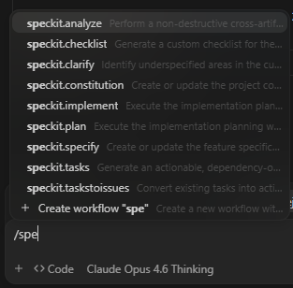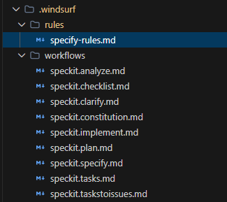
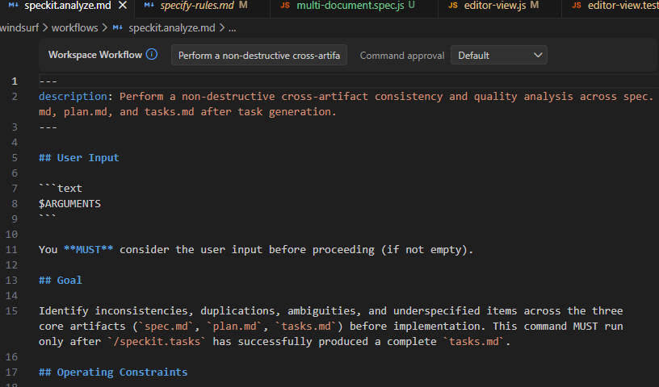

Section 5 — SDD in 10 minutes (the only theoretical part of the workshop)
Duration: 10 minutes
Goal
Provide the only theory section of the session.
Topics
- why not vibe coding
- what Spec-Driven Development means in practice,
- why the flow is structured,
- why we separate specification, clarification, planning, tasks, and implementation,
- what “constitution” means at project level.
Outcome
Attendees understand the reasoning behind the process and are ready to execute it.
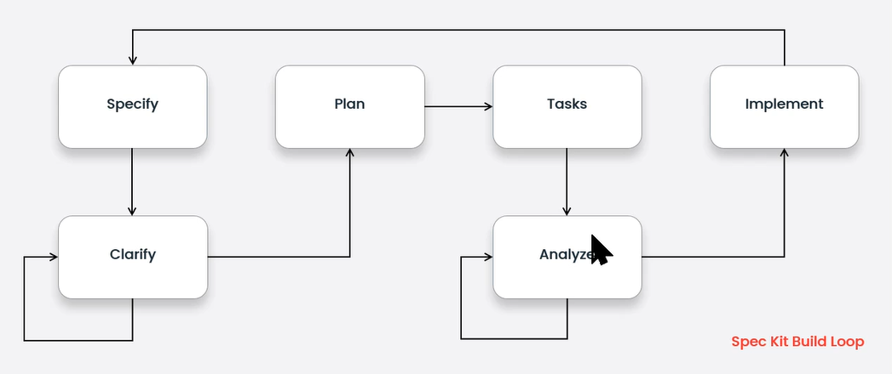

Section 6 — Spec Kit bootstrap / verify and explain structure
Duration: 20 minutes
Goal
Show how Spec Kit is present in the project and what the generated structure is used for.
Note: Here only the trainer/presenter will be installing the SpecKit (that means the trainer will need to have installed Python + UV). Or the attendees that want to install it, use the Empty folder. But all the attendees already have “installed” the SpecKit in the project they will download from GitLab.
Topics
- install Spec Kit,
- explain the scripts,
- explain the markdown files,
- explain the main folders and their role,
- explain the difference between Bash and PowerShell script variants.
Outcome
Attendees understand the toolkit structure without spending too much workshop time on installing it on their own and raw installation details.
Notes for the trainers
Using WSL with Ubuntu distro (python3 is included in all modern ubuntu versions) to install it.
Install uv uvx
curl -LsSf https://astral.sh/uv/install.sh | sh
Install speckit one time – in existing project
uvx --from git+https://github.com/github/spec-kit.git specify init --here
Or with Windsurf and PowerShell chosen as command parameters
uvx --from git+https://github.com/github/spec-kit.git specify init --here --integration windsurf --script ps
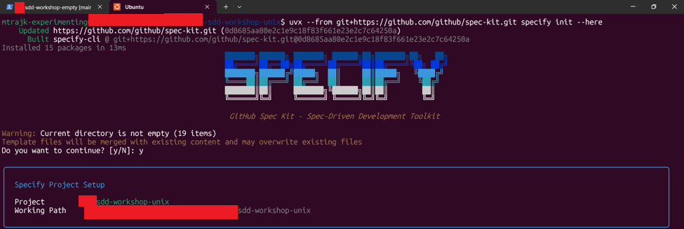
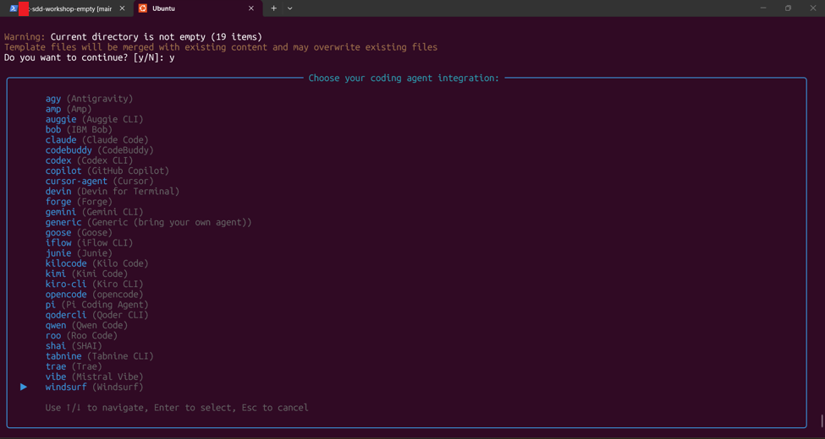
For windows choose ps (powershell)
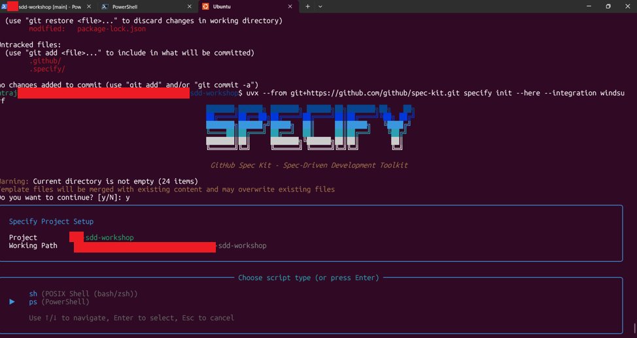
For unix-like (macOS, Linux, WSL) choose sh (bash)
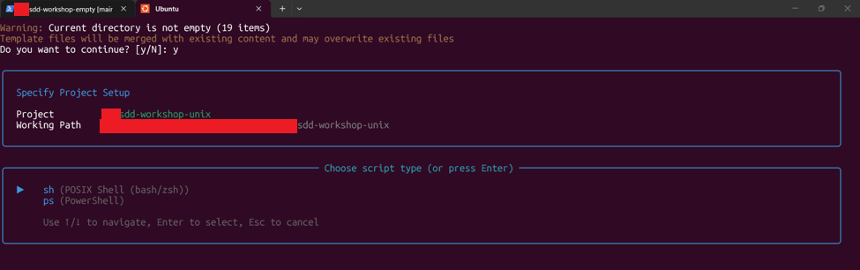
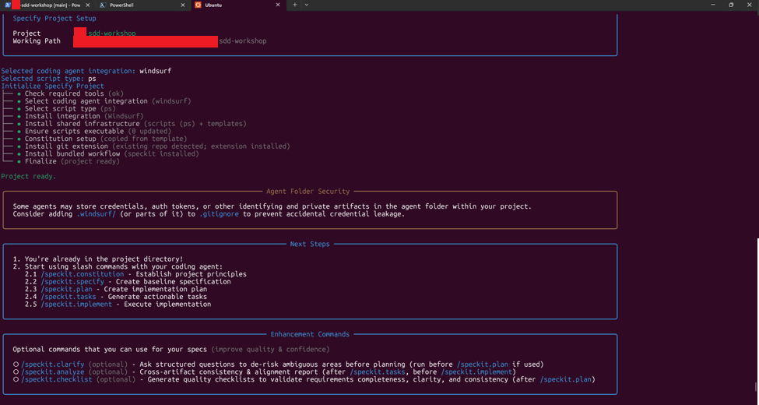
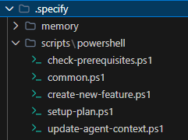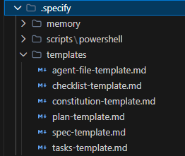
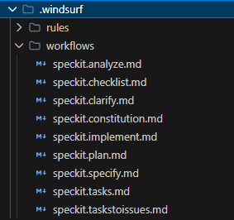

Section 7 — Guided end-to-end feature implementation
Duration: 30 minutes
Goal
Complete one small but realistic feature by following the full SDD flow together.
Flow
The presenter leads the attendees through:
- /speckit.constitution - everyone to establish project principles (this is a fast step, so it’s fine everyone to establish the project principles live – the uploaded project on GitLab is missing intentionally this setup)
- /speckit.specify
- /speckit.clarify
- /speckit.plan
- /speckit.tasks
- /speckit.analyze
- /speckit.implement
Notes
- prompts should be prepared in advance,
- the room should stay on the same branch / state,
- the presenter should avoid improvising the feature request live.
Outcome
Attendees complete one full SDD cycle from request to implementation.
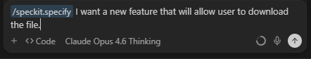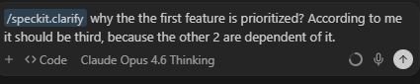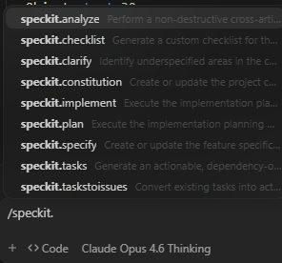

Section 8 — Solo exercise
Duration: 35 minutes
Goal
Allow attendees to use the same process independently.
Format
Each attendee chooses their idea of small feature ideas and repeats the process themselves. Bot not too small feature, for example a feature that will need 3-5 days to be implemented manually.
Ideas:
1. Click dashboard category to filter Expenses page.
2. Dashboard chart type toggle.
3. Bulk select and delete expenses.
4. Category rename.
Outcome
Attendees demonstrate independent use of the process rather than only following the presenter.

Section 9 — Wrap up and Q&A
Duration: 15 minutes
Goal
Allow the attendees to show what they have achieved and start a discussion about the learned process that will motivate them to more ask questions about the whole process.

